
Online Safety. Protecting your Business.
Miquel Àngel París i Peñaranda
Technical English
1st C-VET Cross-platform application development

Index
Online Safety. 3
Software 8
Vocabulary and Functional Language 13
Grammar Practice 17

Online Safety.
- Learn the vocabulary you need. Write the words in your language.
Online Safety
adware | parental control
block | password protect
bulk e-mails | phishing
corrupt | post
ensure | privacy settings
fraudulent | profile
hacker | risk (v)
hide | suspicious
identity theft | thief (thieves)
make public | trick
monitor | undesirable

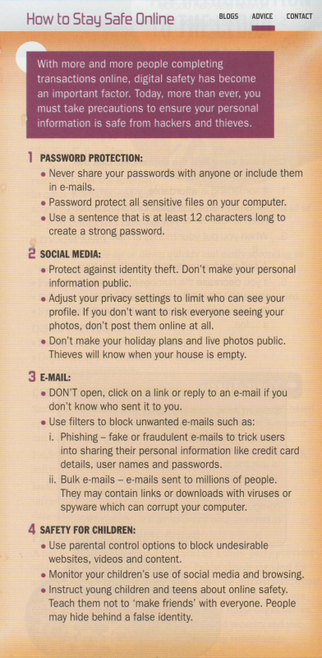
- Read the online advice page. Then decide which tips on the right are mentioned in the article.. ( Audio: Computing_SB_CD4_23)
Tips:
1. Don't give your passwords to other people.
2. Use a different password for each account.
3. Use privacy control. Only let certain people view your personal details.
4. Report spam to your e-mail client.
5. Use filters to reduce spam.
6. Check your children's use of the Internet and social media.

- Two colleagues are discussing Internet security. Choose the correct answer. Then listen to the dialogue and check your answers.)( Audio: Computing_SB_CD4_24)
A: Hi, Katie. My daughter was surfing the web last night and I noticed some undesirable content that I didn't want her to see. I need to block certain ¹ e-mails / websites. Do you know how I can do this?
B: It's easy. Wendy. You can set up your PC to monitor what your children are viewing. It will also keep them away from certain games and sites. You can even set limits on how much time they spend online.
A: You mean I can actually ² limit / decide what sites the browser finds?
B: Sure. Almost all browsers and social media websites have Parental Controls
or Privacy Settings.
A: Where do I find the Parental Controls on Google? How do I ³ set / do them?
B: In your browser, go to Search Settings on the right-hand side of the screen. Under "SafeSearch filters", check the box next to "Turn on SafeSearch". Then at the bottom of the page, click "Save".
A: How does this help?
B: When someone does a search in their browser, this filters the search results and eliminates undesirable videos and websites.
A: Is it completely ⁴ safe / sure?
B: It's not 100% accurate. However, it helps protect children from most of the relevant / Inappropriate search results.

- Read the dialogue in Exercise 2 again. Then match A to B to form sentences.
A
1. Wendy
2. Katie
3. A SafeSearch filter
4. Many social media sites

B
a. may not eliminate al inappropriate material
b. didn't know that parents can limit online access.
c. have got parental controls.
d. recommends filtering search results.

- Working with Vocabulary. Match A to B to make expressions. Then listen and repeat the expressions.. (Audio: Computing_SB_CD4_25)
A
1. identity
2. parental
3. make
4. privacy
5. password
B
a. settings
b. public
c. protect
d theft
e. control

- Copy and complete the sentences below with the expressions from Exercise 5.
1. Think twice before you … your private information.
2. Using … ,you can adjust what different people see on your Facebook page.
3. … is a very serious crime
4. … your account with a combination of letters, numbers and symbols.
5. Fathers and mothers should think about putting … onto the family PC

- Listen and repeat the words in colour. Then choose the correct answer. (Audio: Computing_SB_CD4_26)
1. A hacker / profile contains a person's personal information.
2. Using another person's credit card without permission is fraudulent / undesirable.
3. It's important to ensure / hide your children are safe on social networking sites
4. A firewall can trick / block unauthorised users from accessing a network.
5. Do you think parents should post / monitor their children's access to the Internet?
6. Viruses can corrupt / risk the information on your computer files.

- Listen and repeat the words in colour. Which pairs of sentences have got a similar meaning? (Audio: Computing_SB_CD4_27)
1. a. You should delete an e-mail that seems suspicious
b. If you don't know the source of an e-mail. throw it out
2. a. Phishing messages look like they come from a reputable company.
b. Reputable companies send messages as a way of getting more customers.
3. a. Adware collects information about users Internet activities
b. Adware analyses which websites a user visits
4. a. Thieves can use your credit card details to purchase products from websites.
b. Most people use their credit cards to purchase online today.
5. a. Companies often send out bulk e-mails.
b. To get to all their clients, companies send out thousands of e-mails at the same time

- Match A to B to form sentences.
A
1. You could meet undesirable people
2. A hacker can change
3. Fake e-mails can trick users into
4. Learn how to hide your online identity
5. You can post a helpful reply
6. You risk losing your privacy
B
a. giving away vital information
b. on social networking sites.
c. when you share too much personal information
d. on this forum.
e. and be anonymous on the web.
f. information on your computer system,

- Your Turn. Listen to the conversation between a bank employee and a client. Complete the chart. Then tick (√) the correct columns. (Audio: Computing_SB_CD4_28)
Who...? | Client | Bank Employee
1. reported the scam
2. was suspicious because of the logo
3 knew about the phishing
4. wanted to prevent this from happening again
5. wil adjust the fiters

Software
- Learn the vocabulary you need. Write the words in your language.
CYBER SECURITY
agenda | multi-factor authentication
attempt | penalty
aware of | real-time protection
breach | reassess
cyber attack | recovery
e-commerce | safeguard
encrypt | sensitive
establish | tools
gain entry to | VPN (Virtual Private Network)
malicious code

- Read the e-mail. Then choose the correct answers to the questions on the right according to the text. (Audio: Computing_SB_CD4_29)
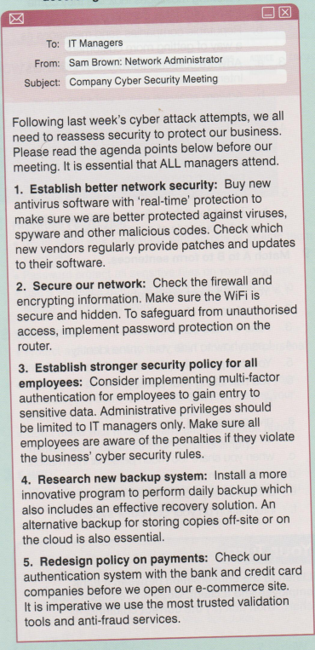
1. Sam Brown is insisting that.....
a. IT managers participate in the meeting
b. all employees read the agenda
2. Sam Brown believes that the company needs to
a. update its antivirus software
b. replace its antivirus software
3. The company has got cyber security rules...
a. which allow employees to see all data
b. which employees mustn't violate
4. The company would like a backup program which
a provides a way to recover data
b. stores data on the cloud
5. The company is planning to
a. sell products online
b. redesign their products

Tip!)
Multi-factor authentication combines two or more independent credentials: something the user knows, such as a password or a secret question; something the user has got, such as a bank card; and biometric verification.

- An IT security advisor (A) is giving security advice to a business owner (B). Number sections A-C in the correct order to form a dialogue. Then listen to the dialogue and check your answers. (Audio: Computing_SB_CD4_30)
A B: Yes. How else can we make sure our network is completely secure?
A: You should consider installing a VPN - a virtual private network. It offers a much better level of security.
B: How does that work?
A: It works as a private network, even though you are using a public network.
B A: Hi, Mathew. What seems to be the problem?
B: Well Jack, last month we had a serious security breach even though we had installed new anti-virus software.
A: When did you last download an update?
B: Oh! I'm not sure.
A: You need to check for software updates at least once a month
C B: OK, I'll get the IT staff to check that
A: Is there anything else that you're concerned about?
B: Yes, some employees have complained that sometimes they can't access all the programs they need.
b It sounds like we need to reassess the firewall settings. I'll adjust the settings for you. Have you got any other questions?

- Read the dialogue in Exercise 13 again. Then decide whether the sentences are true, false or the text doesn't say.
1. Mathew's company has got new anti-virus software.
2. Mathew updated his new anti-virus software last month.
3. Employees now get increased access to more programs.
4. Adjusting the firewall settings will prevent the employees from accessing programs.
5. Jack recommends reducing risk by using a private network.

- Working with Vocabulary. Listen and repeat the words in colour. Then replace the words in bold with the words in colour.. (Audio: Computing_SB_CD4_31)
safeguarded ⚫ gain entry to ⚫ establish ⚫ agenda ⚫ attempted
1. We weren't able to get into the factory.
2. The manager wanted to create a new department.
3. Hackers tried to get into the bank's network.
4. Before the meeting, we received the list of the topics to discuss.
5. Make sure your computer is protected from malware

- Listen and repeat the words in colour. Then match A to B to form sentences. (Audio: Computing_SB_CD4_32)
A
1. A cyber attack on a government
2. E-commerce is a business transaction
3. If we encrypt all the customer data,
4. Malicious code is used to
5. Special data recovery software
6. Tools are a set of basic accessories
7. A VPN (Virtual Private Network) is a private network
B
a. for software developers.
b. can help you find deleted files.
c. damage data, files and computing systems.
d. over the Internet.
e, built over a public infrastructure.
f. it will be protected.
g can cause chaos.

- Listen and repeat the words in colour. Then use them to complete the dialogues. (Audio: Computing_SB_CD4_33)
real-time protection ⚫ aware of ⚫ multi-factor authentication
A: Is your network secure?
B: Yes. I am ¹ … the problem, so I've got some good ² … .
A: Have you considered using ³ … ?
B: Yes, I have, but I've decided not to do that at the moment.
penalty ⚫ reassess ⚫ breach ⚫ sensitive
A: We had a data ⁴ … last week, so our company is very ⁵ … about security. I can't give you my password.
B: What's the for ⁶ ... doing this?
A: The manager will ⁷ … my contract and I could find myself withouta job.

- Choose the correct answer.
1. This is sensitive / trusted information, so please don't discuss it with anyone.
2. Releasing this information is considered a security tool / breach.
3. You need to safeguard / attempt your network against unauthorised entry.
4. What is the penalty / agenda for coming late to work?
5. Hackers were able to gain entry to / establish the accounting system.

Vocabulary and Functional Language
- Mark TWO correct answers. Which of the following...?
1. are criminals
a. hacker
b. adware
c. thief
2. can cause harm
a. profiles
b. phishing messages
c. identity theft
3. provide security
a. bulk e-mails
b. parental control
c. privacy settings
4. should be done to stay safe online
a. block spam
b. make your personal details public
c. password protect
- Complete the puzzle according to the clues.
Across →
3. Many parents block their children from... activities online.
4. A scam is when someone tries to... you.
5. Unauthorised access to a company's files is....
7. You cannot usually open a file that is....
Down ↓
1. If an e-mail looks... don't open it.
2. Do you think parents should... their children's Internet activities?
6. Most companies... their files are backed up at the end of the day.

 |  |  |  |  | 1
 | 2
3
 |  |  | 4
5 |  |  |  |  |  |  | 6
 |  |  | 7

- The words in bold are in the wrong sentences. Write them next to the correct sentences.
1. Some companies send profiles to tell their customers about an event. ___
2. Adware can happen if you don't keep your personal information private. ___
3. You don't post losing money if you buy from a reputable company. ___
4. Registered users create bulk e-mails on social networking websites. ___
5. Gamers often risk their real identity when playing games online. ___
6. Identity theft is offered to customers who don't want to pay for software. ___
7. People sometimes hide a question on a forurn when they need advice. ___

- Complete the correct word or phrase next to its definition.
1. the act of getting back something lost
r...
2. to start something such as a company
e...
3. something that causes data theft
m… c...
4. to examine or think about something again
r...
5. a violation
b...
6. doing business over the Internet
e-…
7. reveal, make known
m… p…

- Point the correct continuation. Pay attention to the words in bold.
1. An agenda tells us......
a. the time and place of the meeting
b. what we will discuss at the meeting
2. There is a penalty if you......
a. reschedule your visit
b. don't pay on time
3. The passwords are encrypted in order to....
a. enrich the program
b. provide full security
4. Real-time protection should....
a. protect your computer from all viruses
b. update your database
5. Cyber attacks use damaging codes and malware to
a, install important information
b. change computer data
6. In order to gain entry to the system, you must....
a. have the correct password
b. have a third-party program

- Complete the sentences with the words and phrases below.
virtual private network ⚫ safeguarded ⚫ attempted ⚫ tools ⚫ sensitive ⚫ multi-factor authentication ⚫ aware of
1. To get money out of my bank, I need …-my bank card and a password.
2. We weren't … the problem until we tried to get into the Internet.
3. Hackers ... to steal data from our customers.
4. These are … documents, so please don't make them public.
5. If the system isn't …, It may be accessed by unauthorised users.
6. Companies use a … to communicate confidentially over a public network.
7. I used these drawing … to create the poster.

- Say It! Write the sentences in your language.
1. Is there anything else that you're concerned about?

2. It's not 100% accurate.

3. When did you last download an update?

4. It sounds like we need to reassess the firewall settings.

5. You need to check for software updates at least once a month.

6. You can set up your PC to monitor what the children are viewing.

7. A VPN network offers a much better level of security.

8. I'll adjust the settings for you.

Grammar Practice
Present Simple Passive
- Complete the chart with the past participle of each verb.
Verb | Past Participle
1. establish
2. put
3. improve
4. do
5. tell
6. write
7. spend
8. break

- Write sentences with the correct form of the verbs in brackets. Use the Present Simple Passive affirmative.
1. Anti-virus software ...(install) on every new computer.
2. Networks ...(set up) by the IT department.
3. Invoices ...(send) to customers at the end of the week.
4. The shop floor ...(clean) once a day.
5. Designs ...(modity) by the graphic artists.
6. Laptops ...(keep) in this part of the shop.
7. I ...(pay) my salary at the beginning of the month.
8. Gifts ...(give) to employees at Christmastime.

- Write sentences about the pictures with the words below. Use the affirmative or negative form of the Present Simple Passive.


technical support / often / give / at night

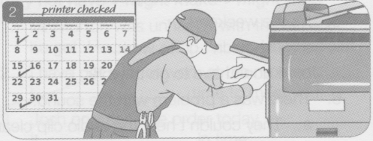

the printer / check / every week

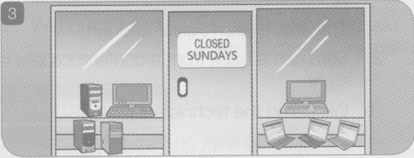

repairs / do / on Sundays

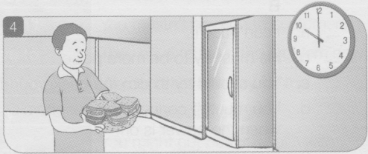

sandwiches / deliver / at ten o'clock

- Write questions with the words below. Use the Present Simple Passive. Then match the questions in A to the answers in B.
A
1. why / Mrs Hunt's office door / lock
…?
2. when / lunch / serve
…?
3. what / hardware / sell / here
…?
4. the flight stick / include / in the price
…?
5. where / the billing addresses / store
…?
B
a. Yes, it is.

b. In the database.

c. Because she's not here today.

d. Computer peripherals.

e. From 12.00 to 2.00.

- Mark the correct answer.
1. These scanners make / are made in China.
2. A router needs / is needed to operate this network.
3. We give / are given our regular customers a discount.
4. Computers in the office back up / are backed up every day.
5. The SafeSearch feature filters / is filtered the search results.
6. This laptop model uses / is used by many students.

- Complete the sentences with the verbs in brackets. Use the Past Simple Passive.
1. This program ...(create) by our programmers.
2. The conference reservation ...(make) last week.
3. This repair ...(not do) correctly.
4. The new gadgets ...(review) in the newspaper.
5. The shop's hours ...(not increase) recently.
6. All the old peripherals ...(dispose of) last week.

- Write questions for each answer. Pay attention to the words in bold.
1. …?
The goods were sent two days ago.
2. ...?
No, the missing equipment wasn't found.
3. …?
Everyone was sent home because of the fire.
4. …?
Jane was given the job.
5. …?
The sales meetings were held in London.

- Read the mini-dialogues and point the correct answer.
1. A: Where is the part we ordered?
B: It lost / was lost in the post.
2. A: Where did Mary put the invoices?
B: She left / were left them with the accountant.
3. A: Where are the new gaming accessories?
B: They sold / were sold yesterday.
4. A: How is the new programmer doing?
B: He gave / was given some positive feedback yesterday.
5. A: Is our network more secure now?
B: Yes. Some changes made / were made to ensure a better level of security.

